1.Butterworth IIR Filters
1.1. Design and Analysis of a Butterworth IIR Low-Pass Filter Using MATLAB
Program (MATLAB Code)
clc;
clear;
close all;
Fs = 10000;
Fp = 1000;
Fst = 1500;
[N,Wn] = buttord(Fp/(Fs/2),Fst/(Fs/2),1,60);
[b,a] = butter(N,Wn);
% Frequency Response
figure;
freqz(b,a);
% Impulse Response
[h,n] = impz(b,a,50);
figure;
stem(n,h,'filled');
grid on;
xlabel('Samples');
ylabel('Amplitude');
title('Impulse Response');
% Step Response
figure;
stepz(b,a);
% Pole-Zero Plot
figure;
zplane(b,a);
fprintf('Minimum Filter Order (N) = %d\n',N);
fprintf('Cutoff Frequency (Wn) = %.4f\n',Wn);
OUTPUT:
Minimum Filter Order (N) = 17
Cutoff Frequency (Wn) = 0.2083

Fig.1
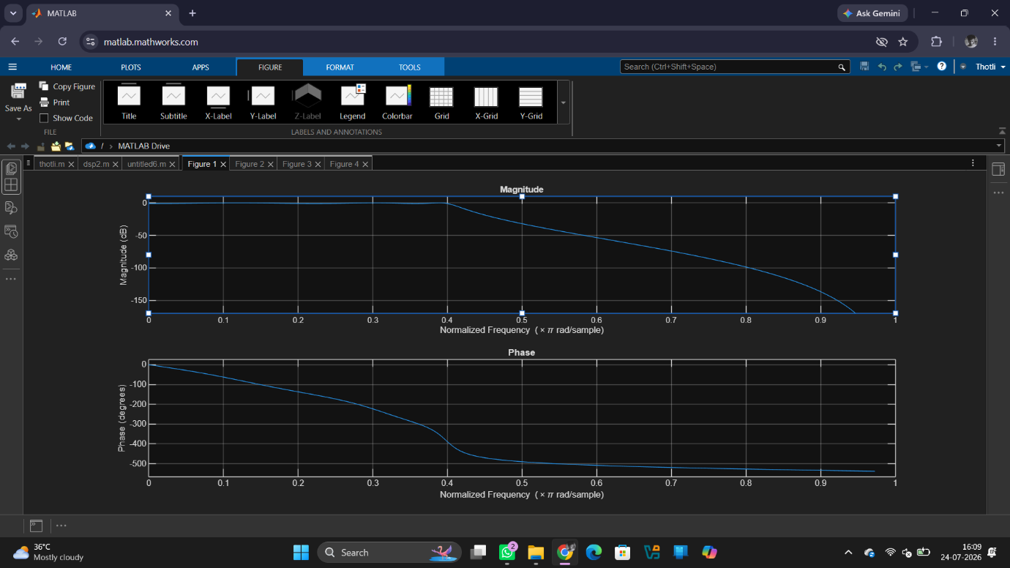

Fig 2
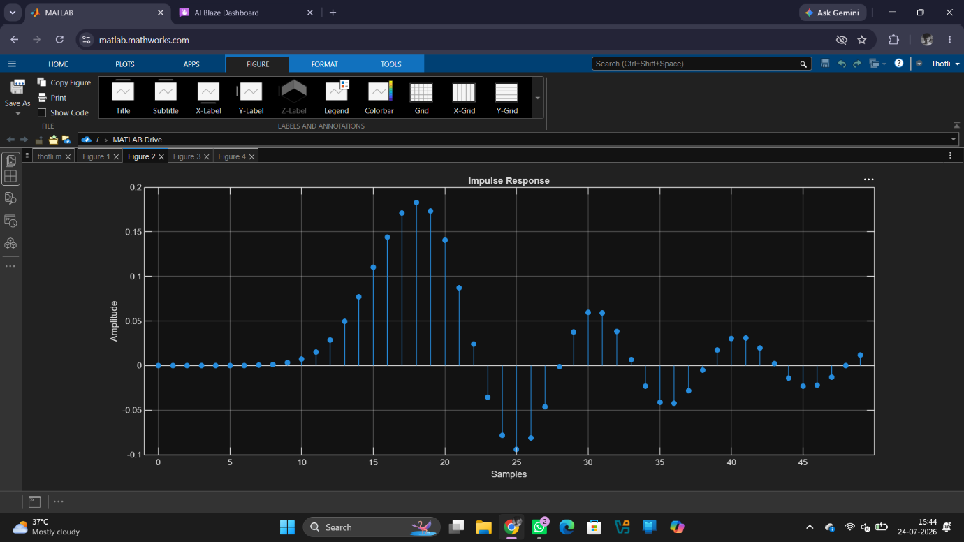

Fig 3
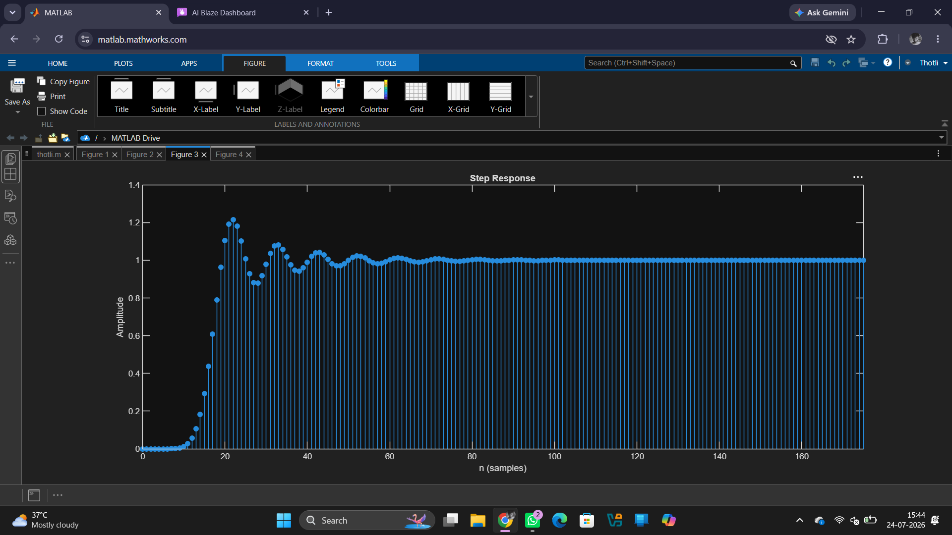

Fig 4
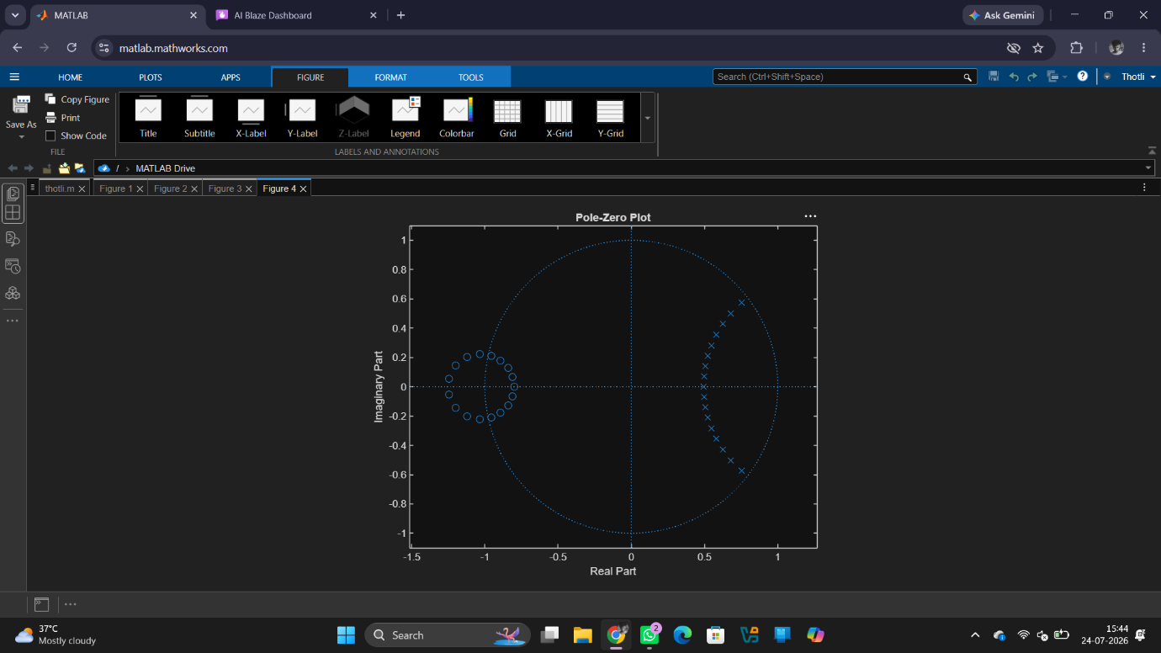
Result:
1.The minimum filter order and cutoff frequency satisfying the given specifications were determined successfully.
2.The magnitude and phase responses of the Butterworth IIR low-pass filter were obtained and analysed.
3.The impulse response, step response, and group delay characteristics were evaluated successfully.
4. The pole-zero plot confirmed the stability and proper performance of the designed filter.

